**OHM’S LAW - KIRCHOFF’S LAW**

Electricity and Light

TA name: Jason Pero Due Date: 10/5/21

Student Name: Landon Moon

Student ID: 1001906270

**Theory:**

A D.C. circuit consists of sources of direct current (EMFs), connected to a network of elements. If the elements are ohmic (obey Ohm’s Law) then the currents through the elements are directly proportional to the voltages applied across the elements. For ohmic elements, the relation between the current through an element (I), in amps, and the voltage across the element (V), in volts, is

V = IR [1]

where R is the resistance of the element in ohms. Resistors, which are commonly used in electronic devices, are ohmic.

If two or more resistors are connected in series with a voltage source, as illustrated in Figure 18-1, they collectively behave as an equivalent single resistor with resistance, Rser, where

Rser = R1 + R2 + R3 + … + Rn [2]

R1

R2

R3

Rn

V

Figure 18-1

the resistors are connected in parallel to the voltage source, as illustrated in Figure 18-2, then they collectively behave as an equivalent single resistor with a resistance, Rpar, where

Figure 18-2

V

Rn

R3

R2

R1

 [3]

The circuits illustrated in Figures 18-1 and 18-2 can be reduced to a single loop containing a single voltage source and a single resistor. And Ohms Law can be used to determine the currents in the circuit.

If however the circuit contains more than one voltage source in a network of resistors, the circuit usually cannot be reduced to a single loop. Kirchhoff’s rules are useful in analyzing a multi-loop circuit.

**This Prelab is worth 15 points**

**Type all your answers in Blue**

1. Write down an equation and solve for the total resistance of three resistors R1=100Ω, R2=150 Ω, R3=350Ω in the resistors were arranged in the following combination:
2. All three in series (1 point)

100Ω+150Ω+350Ω=600Ω

1. All three in parallel (1 point)

((1/100Ω)+(1/150Ω)+(1/350Ω))^-1=51.21Ω

1. How would you arrange these three resistors to get a net resistance of 410 Ω. (1 point)

Have R1 and R2 in parallel and R3 in series. ((1/100Ω)+(1/150Ω))^-1+350Ω=410Ω

1. If you have an experimental setup which has three unknowns, how many linearly independent equations do you need to determine the unknowns to find one unique solution? (1 point)

You need 6 independent equations for the three unknowns. You need to find a equasion for the voltage and current of each.

1. What is Kirchoff’s law of current? What does it conserve? (1 point)

Kirchoffs law of current says that charge is conserved in a circuit. The total charges going in is equal to the charges going out.

1. What is Kirchoff’s law of voltage? What does it conserve? (1 point)

Kirchoffs law of current says that voltage is conserved in a circuit. The total voltage going in is equal to the voltage going out.

1. Electrical circuits have two main problems: “Short” and “Open”. Define these two conditions with diagram and an example showing the consequence of each of these faults. (Use back of the page if necessary). (2+2 = 4 points)

A short circuit is what happens in a circuit that is closed and has little resistance. This causes a lot of current in a short amount of time.

A Open circuit is what happens in a circuit that isn’t complete. No charge is able to flow so the circuit isn’t opperational.

Open Circuit

Short Circuit

Apply Kirchoff’s law of current and voltage in loop 1 and loop 2 of the above circuit and write down the corresponding equation. (2.5 + 2.5 = 5 points)

R1

R2

R3

I1

I2

I3

V1

V2

I2

I1

Loop 1

Loop 2

Loop I:

Current equation: I1=V1/(R1+R3) I3=I1+I2

Voltage equation: V1-I1R1-I3(R3+R1)=0

Loop 2:

Current equation: I2=V2/(R2+R3) I3=I1+I2

Voltage equation: V2-I2R2-I3(R3+R2)=0

**Part A: Ohm’s Law**

This lab uses the **Ohm’s Law** and **Circuit Construction Kit DC** simulation from PhET Interactive Simulations at University of Colorado Boulder, under the CC-BY 4.0 license.

<https://phet.colorado.edu/sims/html/ohms-law/latest/ohms-law_en.html>

<https://phet.colorado.edu/sims/html/circuit-construction-kit-dc/latest/circuit-construction-kit-dc_en.html>

**Develop your understanding:**

Open [Ohm’s Law](https://phet.colorado.edu/sims/html/ohms-law/latest/ohms-law_en.html), then explore to develop your own ideas about how resistance, current, and battery voltage are related.

1. As you change the value of the battery voltage, how does this change the current through the circuit and the resistance of the resistor? If the current or resistance remains constant, why do you think it is?

🡪 As voltage goes up, current goes up. This is probably because as each electron gets more potential, there is a stronger electric field in the wire. Because there is a stronger electric field electrons will travel faster allowing more to pass though.

1. As you change the value of the resistance of the resistor, how does this change the current through the circuit and the battery voltage? If the current or voltage remains constant, why do you think?

🡪 The higher the resistance the less current there is in the circuit. Resistance slows down the electrons going though a wire. Because the electrons are forced to go slower, less get go through at a time. This causes there to be less electrons per time.

1. Use understanding to make predictions about a circuit with lights and batteries.

🡪 The higher voltage battery would make the light shine brighter because there would be more current. If there is too much current then the light will burn out. A resistor will probably be needed to protect the light.

**Demonstrate your understanding:**

Directions: As you answer the questions,explain in your own words why your answer makes sense and provide evidence from your #1 experiments. Add more experiments to #1 if you need to get better evidence.

2. If you change the value of the battery voltage:

1. How does the current through the circuit change? (answer, explain)

It changes linerally with the voltage. V=IR is a linear equasion.

1. How does the resistance of the resistor change? (answer, explain)

The resistance does not change. Resistance is based on components not voltage.

3. If you change the resistance of the resistor:

1. How does the current through the circuit change? (answer, explain)

The current decreases inversly with the resisistance. I=V/R. The larger risistance is, the lower current will have to be to satisfy the equasion.

1. How does the voltage of the battery change? (answer, explain)

The voltage does not change. Voltage is based on the component its coming from.

4. Consider the two circuits below.

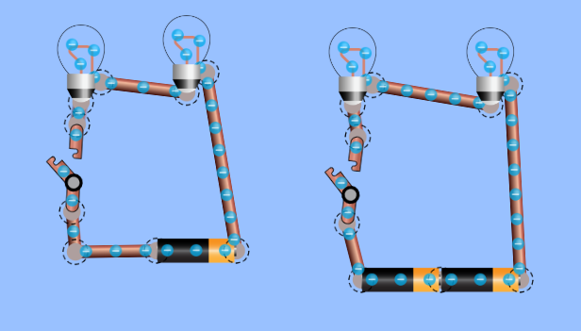

Use your understanding of voltage, resistance, and current to answer these questions:

1. What do you think will happen when the switches are closed?

(answer, explain) The lights will turn on and possibly burn out. By closing the circuit you allow charges to flow through the light bulbs.

1. How do you think the lights’ brightness will compare?

The current going through the first circuit is half that of the second because the second circuit will have double the voltage.

1. Open the [Intro](https://phet.colorado.edu/sims/html/circuit-construction-kit-dc/latest/circuit-construction-kit-dc_en.html?screens=1) screen of Circuit Construction Kit DC. Build 2 circuits. Turn on “values”. An ammeter is used to measure current in a circuit. Use the ammeter to compare the current in the two circuits. Compare and contrast the two circuits. Explain the difference in brightness from the two circuits by relating it to Ohm’s Law.

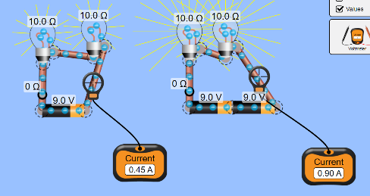The circuit on the left shines half as brightly than the second because it has half the current going through it.

Insert a capture of the circuits with the switch closed for supporting evidence.

5. Consider the two circuits below.

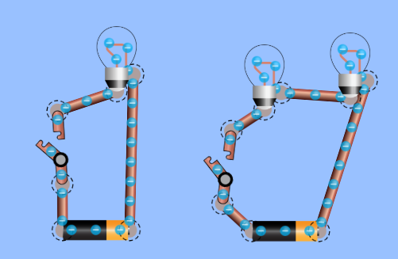

Use your understanding of voltage, resistance, and current to answer these questions:

* What do you think will happen when the switches are turned closed?

(answer, explain, evidence) The light will turn on and electrons will start moving.

* How do you think the lights’ brightness will compare?

The light of the first one will be 2 times that of the light coming from each of the bulbs in the other circuit.

* Open the [Intro](https://phet.colorado.edu/sims/html/circuit-construction-kit-dc/latest/circuit-construction-kit-dc_en.html?screens=1) screen of Circuit Construction Kit DC. Build the 2 circuits and check your answers. Use the values obtatined from the ammeter and Ohm’s Law to explain the difference in brightness from the two circuits.

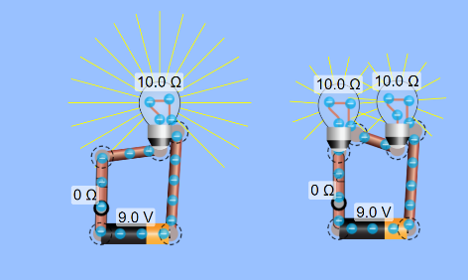The light of the first circuit is brighter than that of the bulbs in the second. The two bulbs are receiving half the current as the other circuit so they shine half as brightly. The total light emitted is the same in both circuits.

Insert a capture of the circuits with the switch closed for supporting evidence

**Part B: Kirchoff’s Law**

**Objectives:**

To investigate Kirchhoff’s Laws: Kirchhoff’s Current Law (KCL) and Kirchhoff’s Voltage Law (KVL).

**Simulation Tools:** DC ‐ Power supply, voltmeter, ammeter, resistors, and connecting wires.

**Theory and Background:**

Kirchhoff’s laws follow from the laws of conservation of energy and conservation of charge. These laws are used to analyze electrical circuits, which contain combinations of batteries, resistors and capacitors. In this experiment, we are interested in investigating Kirchhoff’s laws for a direct current (DC) circuit, for which the electrical currents are constants in magnitude and direction.

The two Kirchhoff’s laws are referred to as Kirchhoff’s Current Law (KCL), also called Junction Rule and Kirchhoff’s Voltage Law (KVL), also called Loop Rule.

**Kirchhoff’s Current Law (KCL):**

*The sum of the currents entering any junction, in a closed circuit, must equal the sum of the currents leaving it; or the algebraic sum of all currents at that point is zero*,

ΣI = 0 ……..………….. (1)

This law is a restatement of charge conservation.

**Kirchhoff’s Voltage Law (KVL):**

*The algebraic sum of the changes in potential around any closed path of a closed circuit is equal to zero*. In mathematical terms, this statement can be expressed as:

Σε + ΣIR = 0 ……………… (2)

**Procedure**

**Circuit 1:**

1. Click on the following link from PHET Colorado Simulation to open the lab

<https://phet.colorado.edu/sims/html/circuit-construction-kit-dc/latest/circuit-construction-kit-dc_en.html>

1. Choose Conventional Current
2. Use the components in the left side to build the circuit shown below: Note* there is a larger resistor in the components menu.

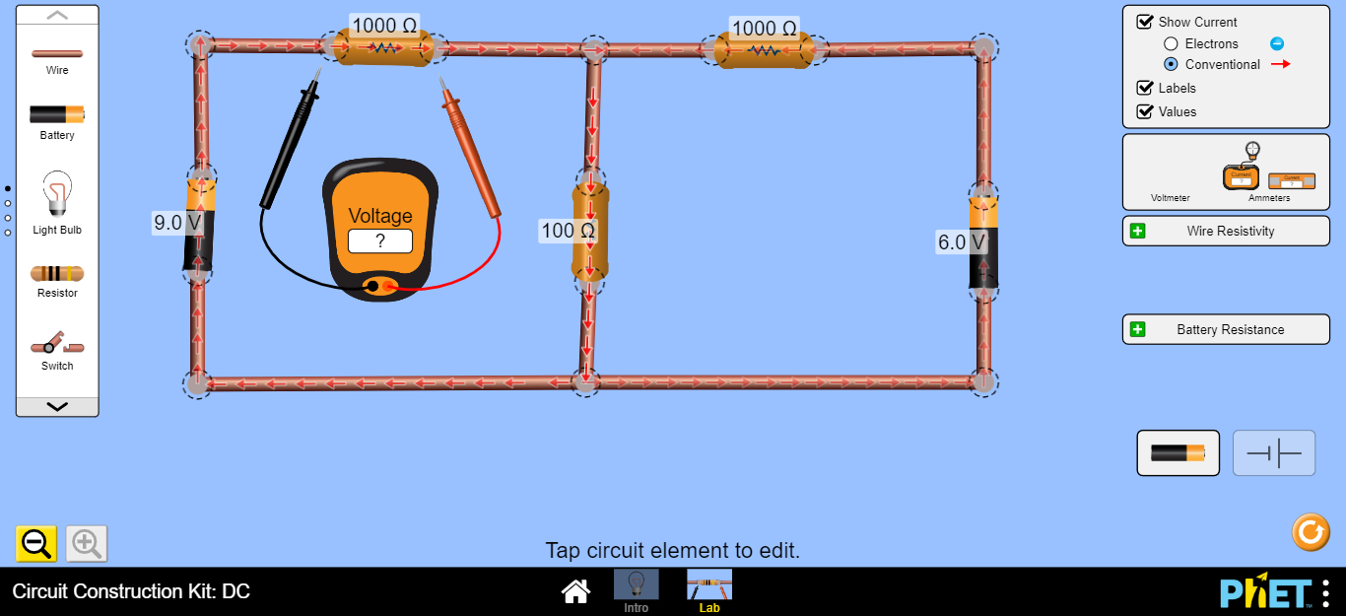

R1

R2

R3

ε1

ε2

1. Click on the resistor (R1) and fix it at 1000Ω. That is R1 = 1000Ω.
2. R2 = 1000Ω and R3 = 100Ω
3. Click on the Battery to the left (ε1) and fix it at 9V, ε1 = 9V.
4. Click on the Battery to the right (ε2) and fix it at 6V, ε2 = 6V
5. Click on the Voltmeter from the right side and drag it to measure (V1) the voltage across R1, (V2) the voltage across R2 and (V3) the voltage across R3.
6. Click on the Ammeter from the right side and drag it and put it in series with R1 to measure (I1), with R2 to measure (I2) and with R3 to measure (I3).
7. Record the values (I1, I2, I3, V1, V2 and V3 ) into table 1.

**Table 1**

|  |  |  |  |  |  |
| --- | --- | --- | --- | --- | --- |
| ε1 = 9V…………………………… ε2 = 6V……..................... | | | | | |
| **Experimental results** | | | **Calculated results (use the loops)** | | |
| R (Ω) | I (A) | V (volt) | R (Ω) | I (A) | V (volt) |
| 1000 | .008A | 7.75V | 1000 | .00818A | 8.18V |
| 1000 | .005A | 4.75V | 1000 | .00545A | 5.45V |
| 100 | .012A | 1.25V | 100 | .01363A | 1.37V |

Show your mathematical calculations here:

**I1=ε1/(R1+R3)=.00818A**

**I2=ε2/(R2+R3)=.00545A**

**I3=I1+I2=.01363A**

**V1=I1R1=8.18V**

**V2=I2R2=5.45V**

**V3=(ε1+ε2)-V1-V2=1.37V**

**Questions:**

1. Using your experimental results of I1, I2 and I3 from Table 1 and Circuit 1, verify the Kirchhoff’s current law (KCL). Kirchhoff’s law states that the current going into a curcuit is the same going out. The total current of the first circuit is I=V/R=.00818A and the total of the second is .00545A. kirchhoffs second law states that at a junction these currents add up I3=I1+I2=.01363A
2. Using your experimental results of V1, V2 and V3 from Table 1 and Circuit 1, verify Kirchhoff’s voltage law (KVL). Kirchhoff’s law states that the voltage going into a circuit is equal to the total voltage in a the circuit. The total voltage of both loops is 15V=8.18V+5.45V+1.37V. The voltage of the first loop is 9V. The first resistor has 8.18V which means the voltage after the second resistor going back to the first loops battery is .82V. similarly the voltage of the second loop is 6V and the first resistor is 5.45V which means the voltage from the second resistor to the second loop is .55V. the two voltages going out of the second resistor is equal what is in the resistor which is 1.37=.82V+.55V.

**Conclusions:**

* (for Ohm’s Law)

Ohm’s law is very usefull for determing the voltage, resistance, and amperage of specific components of a circuit. You need to know two in order to get the third so it has its limitations.

* (for Kirchoff’s laws)

Kirchoff’s law fills in the limitations of ohm’s law. By knowing multiple values of either voltage or current of components in a circuit, you can determing other values. You can also determine what parts of a circuit have to be equal to eachother giving you more tools in your toolbelt to figure out the problem.

**Circuit 2: (Extra credit: 15 points)**

**Build the follwing cicuit. Note* you can reset the screen if it’s easeier by clicking the reset button on the bottom right corner.**

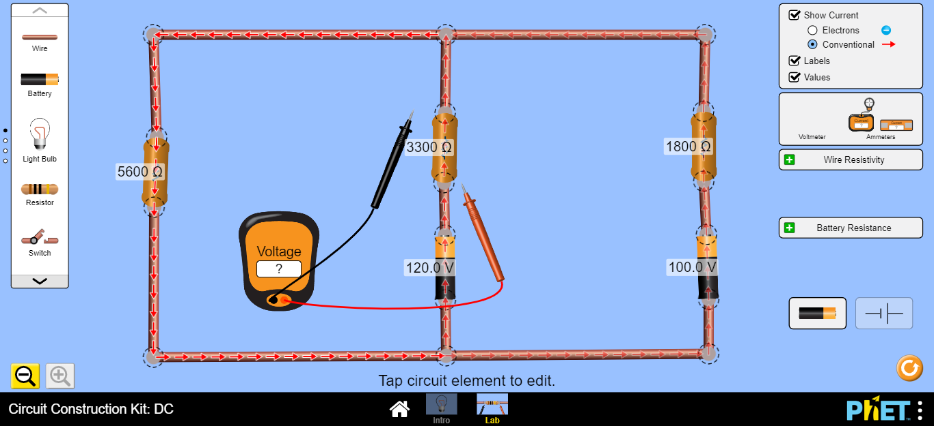

R1

R3

R2

ε1

ε2

1. Click on the resistor (R1) and fix it at 5600Ω. That is R1 = 5600Ω.
2. R2 = 3300Ω and R3 = 1800Ω
3. Click on the Battery to the left (ε1) and fix it at 120V, ε1 = 120V.
4. Click on the Battery to the right (ε2) and fix it at 100V, ε2 = 100V
5. Click on the Voltmeter from the right side and drag it to measure (V1) the voltage across R1, (V2) the voltage across R2 and (V3) the voltage across R3.
6. Click on the Ammeter from the right side and drag it and put it in series with R1 to measure (I1), with R2 to measure (I2) and with R3 to measure (I3).

Record the values (I1, I2, I3, V1, V2 and V3 ) into table 2.

**Table 2**

|  |  |  |  |  |  |
| --- | --- | --- | --- | --- | --- |
| ε1 =120V ε2 = 100V | | | | | |
| **Experimental results** | | | **Calculated results (use the loops)** | | |
| R (Ω) | I (A) | V (volt) | R (Ω) | I (A) | V (volt) |
| 5600 | .016A | 88.58V | 5600 | .0158A | 88.626V |
| 3300 | .010A | 31.42V | 3300 | .0095A | 31.374V |
| 1800 | .006A | 11.42V | 1800 | .0063A | 11.374V |

Show your calculations here:

V1+**V2=ε1**

**V1+V3=ε2**

**V1=ε2-V3=ε1-V2**

**V2=V3+(ε1-ε2)**

**V2=V3+20V**

**I2+I3=I1=V2/R2+V3/R3=V1/R1**

**(V3+20)/R2+V3/R3=V1/R1**

**R1((V3+20)/R2+V3/R3)=V1**

**R1(V3/R2+V3/R3+20/R2)=V1**

**R1(V3/R2+V3/R3+20/R2)+V3=ε2**

**… too much to put into text. I just put V3 into terms of ε2 instead of the other way around.**

**V3=11.374V**

**V2=V3+20=31.374V**

**V1=ε1-V2=88.626V**

**I1=V1/R1=.0158A**

**I2=V2/R2=.0095A**

**I3=V3/R3=.0063A**